**Django Website Day 1**

Django installation

Create project

Run server

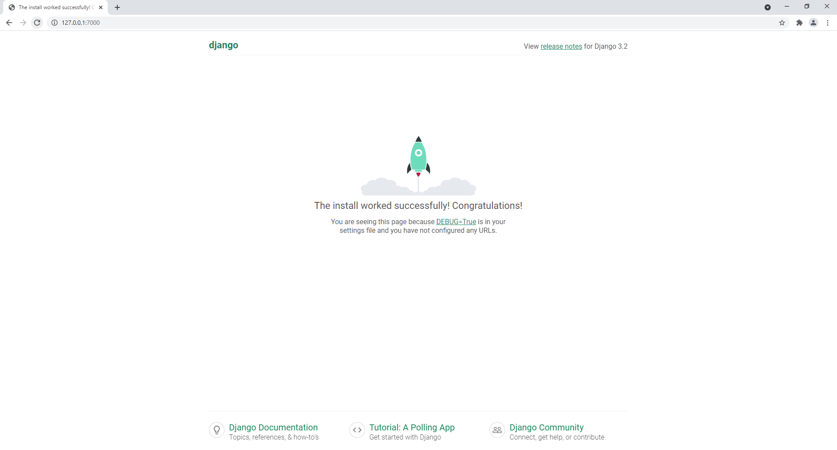

Python installation in visual studio code

